Install Prometheus and Grafana on a Linux EC2 machine, connect Prometheus to Grafana, and create a dashboard to view metrics.

**Techstacks needs to be used :**

* AWS EC2
* Prometheus
* Grafana
* Node Exporter

Step1 : Create EC2 machine

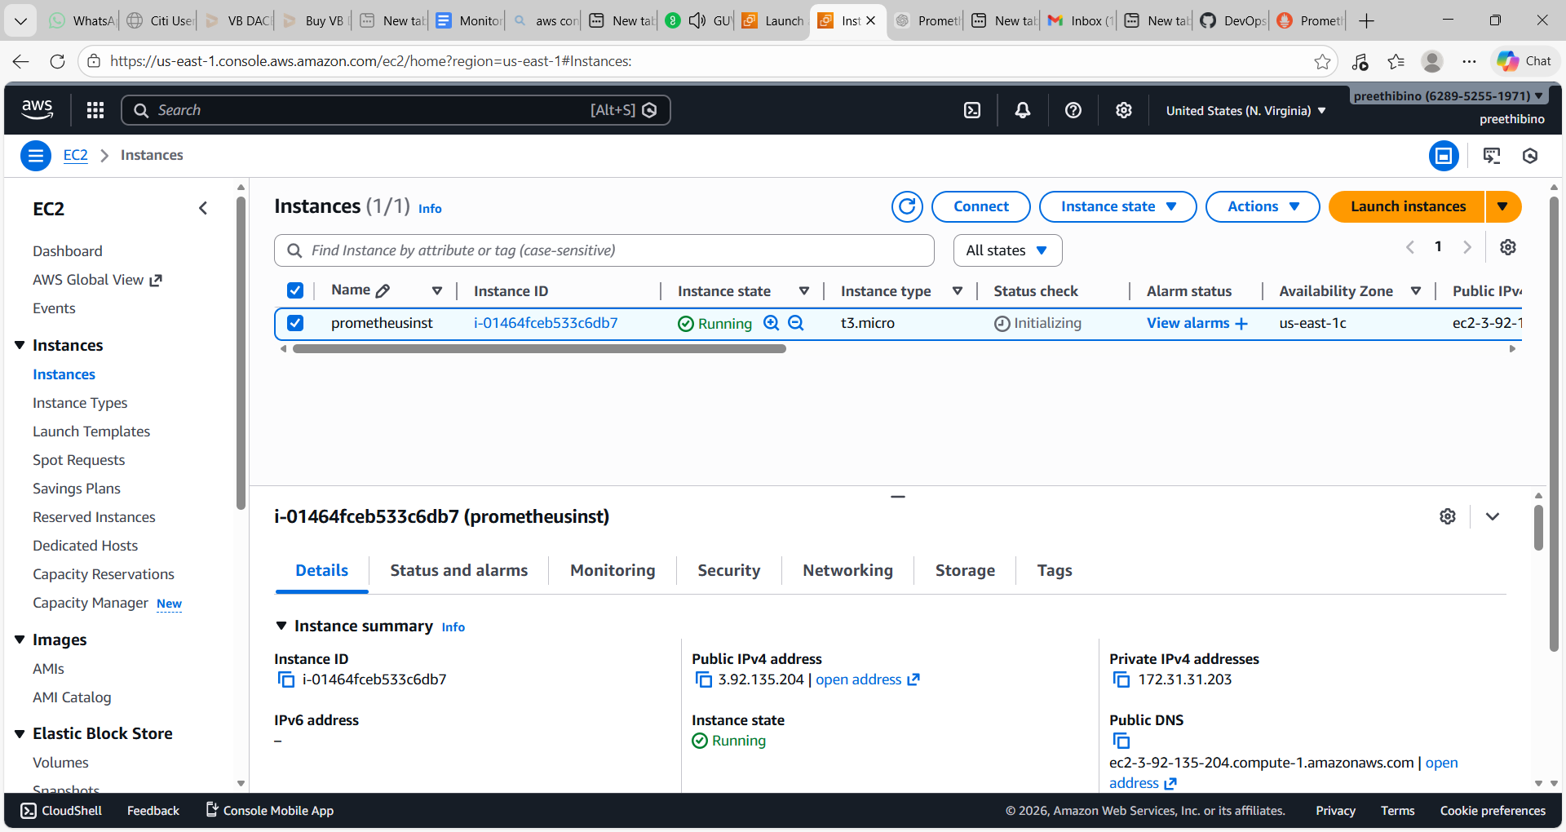

Step 2 – Configure Security group for Grafana port 3000 and Prometheus port 9090

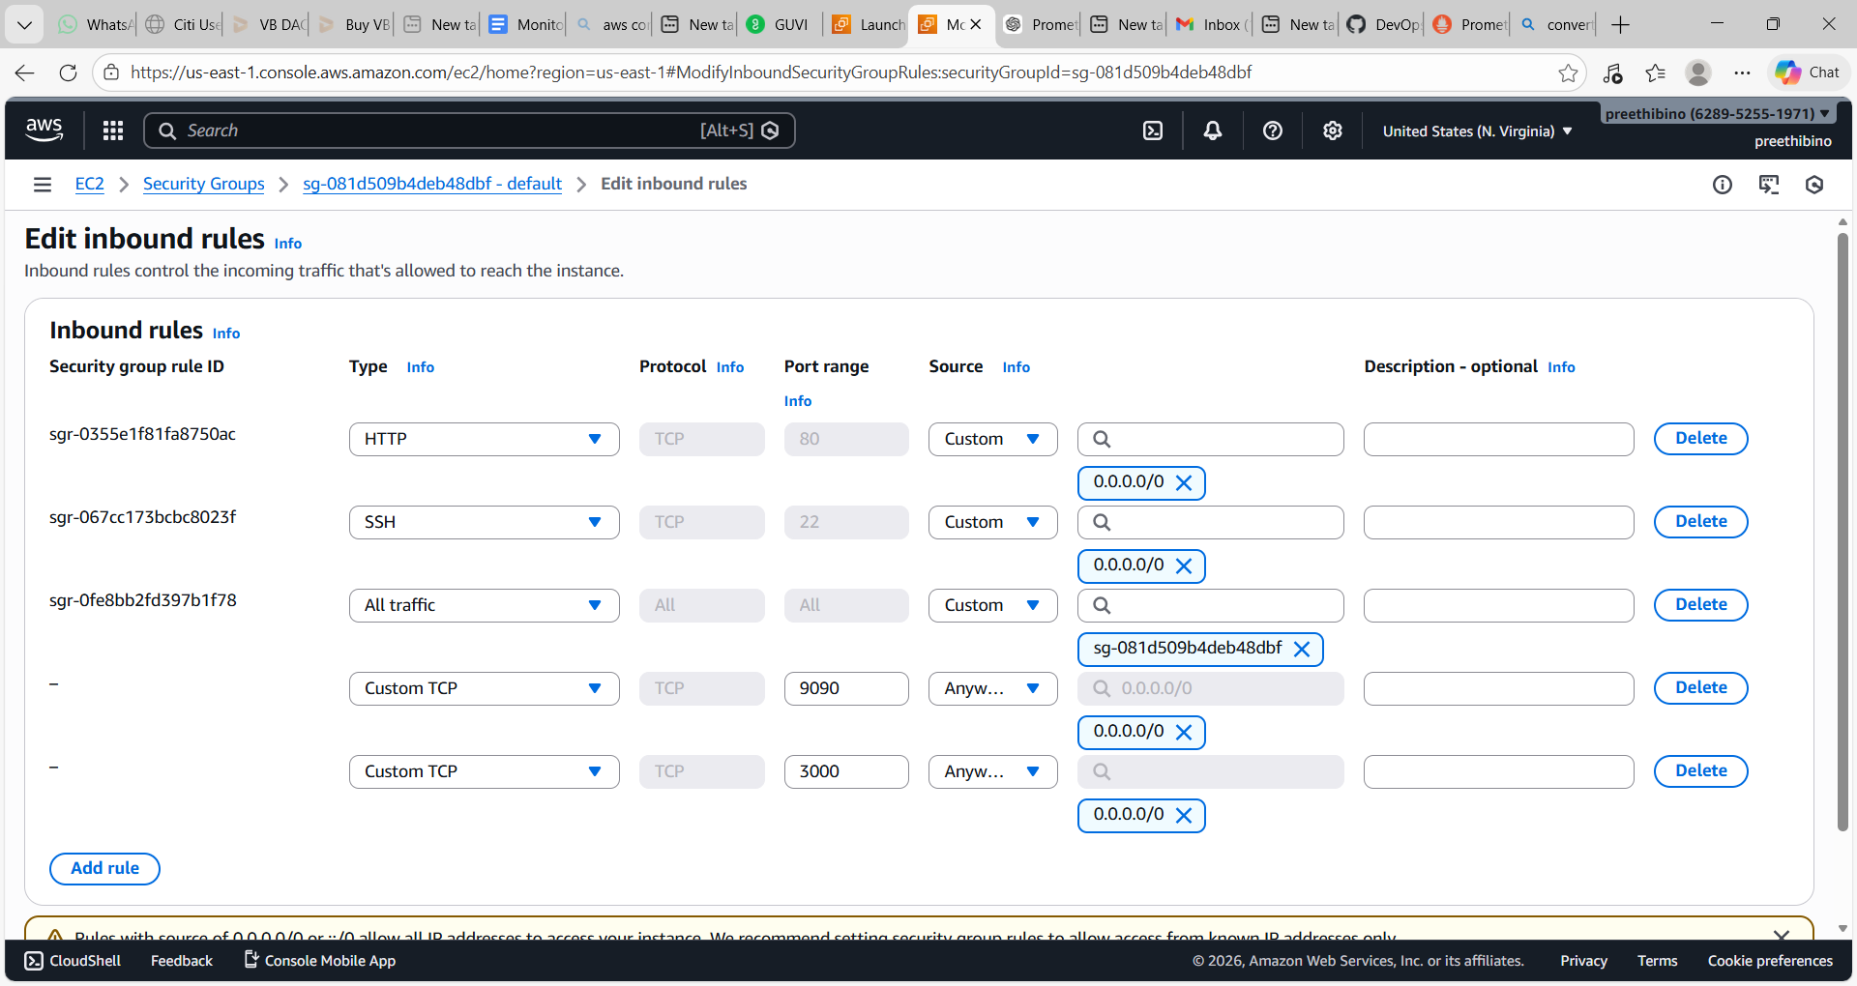

Step 3- Connect to EC2 machine and sudo update

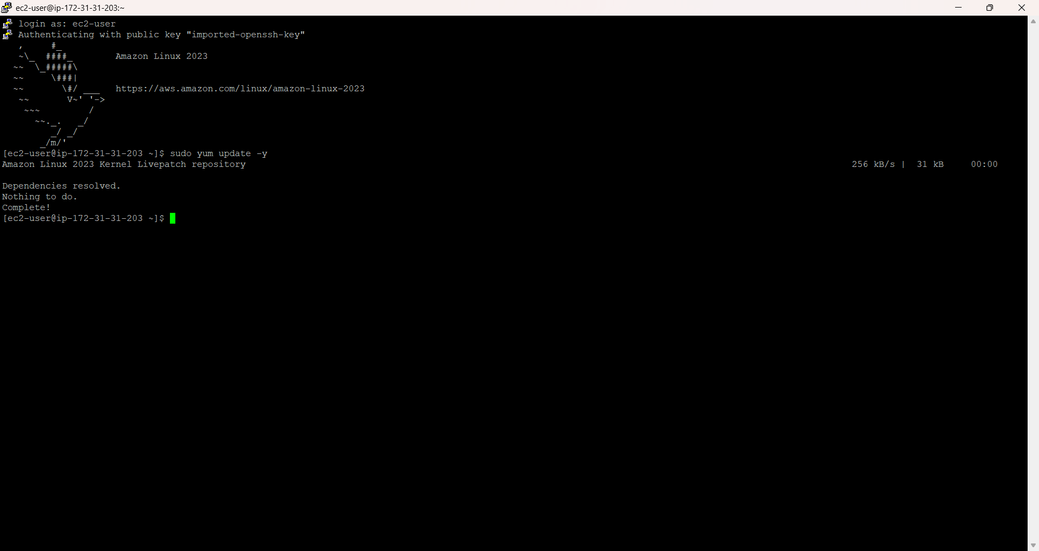

Step 4:install Prometheus with following commands

cd /opt—is a standard Linux directory for installing optional third-party software.

sudo wget <https://github.com/prometheus/prometheus/releases/download/v2.49.1/prometheus-2.49.1.linux-amd64.tar.gz>

(latest version from here [Download | Prometheus](https://prometheus.io/download/))

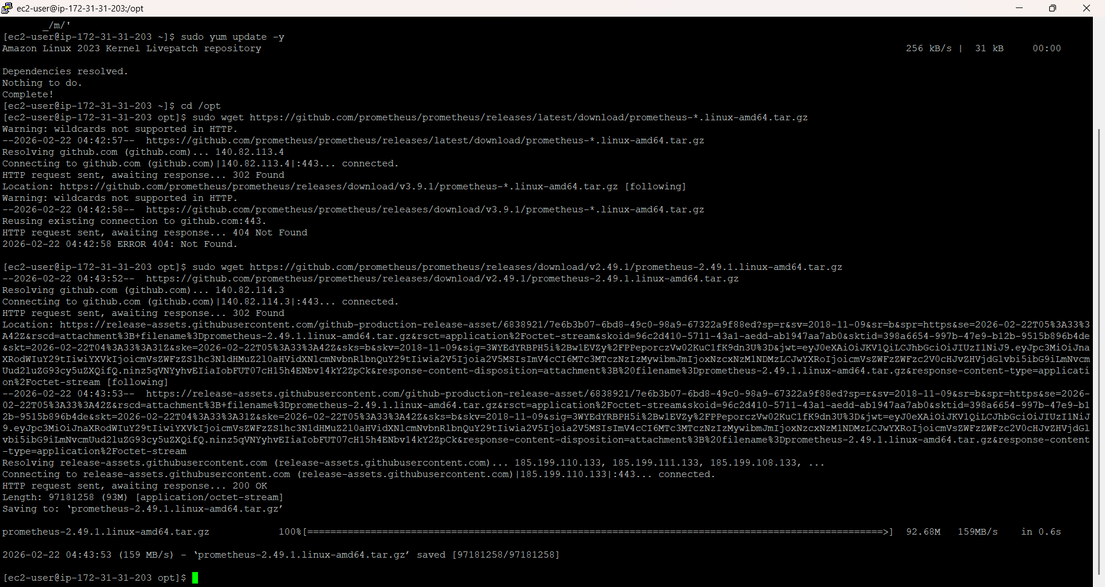

Step 5: Extract it with following commands

sudo tar -xvf prometheus-*.tar.gz  
sudo mv prometheus-2.49.1.linux-amd64 prometheus  
cd Prometheus

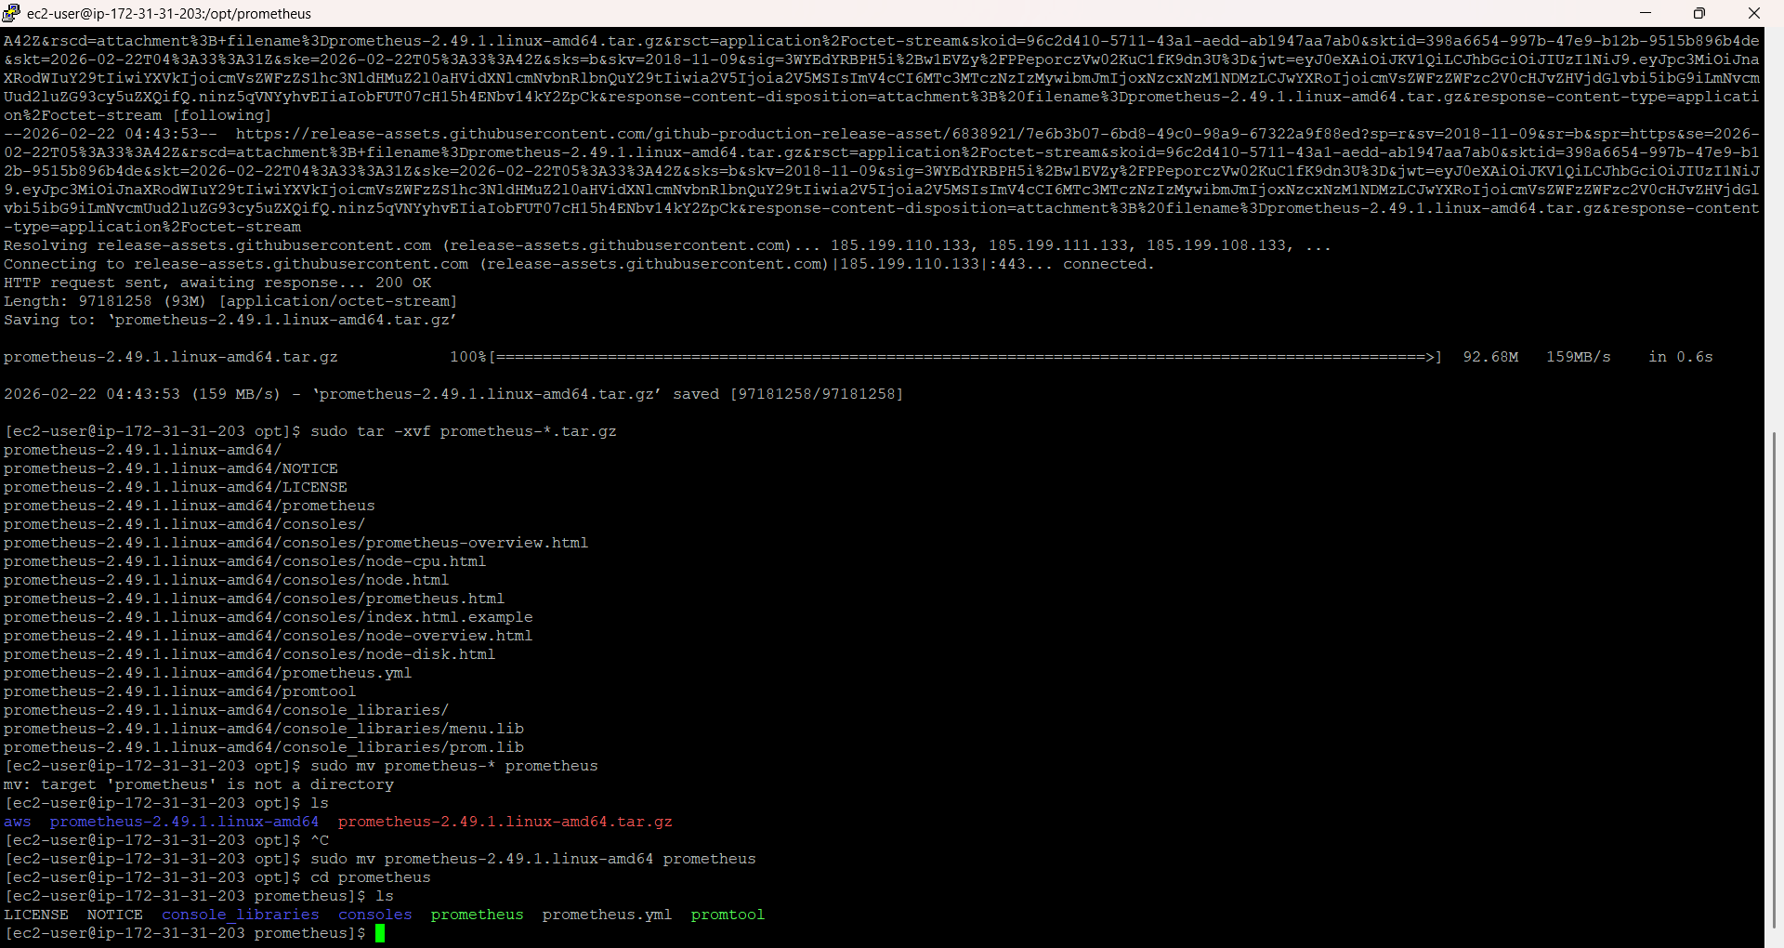

Step 6- Run Prometheus

Sudo mkdir data

sudo chown -R ec2-user:ec2-user /opt/Prometheus (give permission to write)

./prometheus --config.file=prometheus.yml

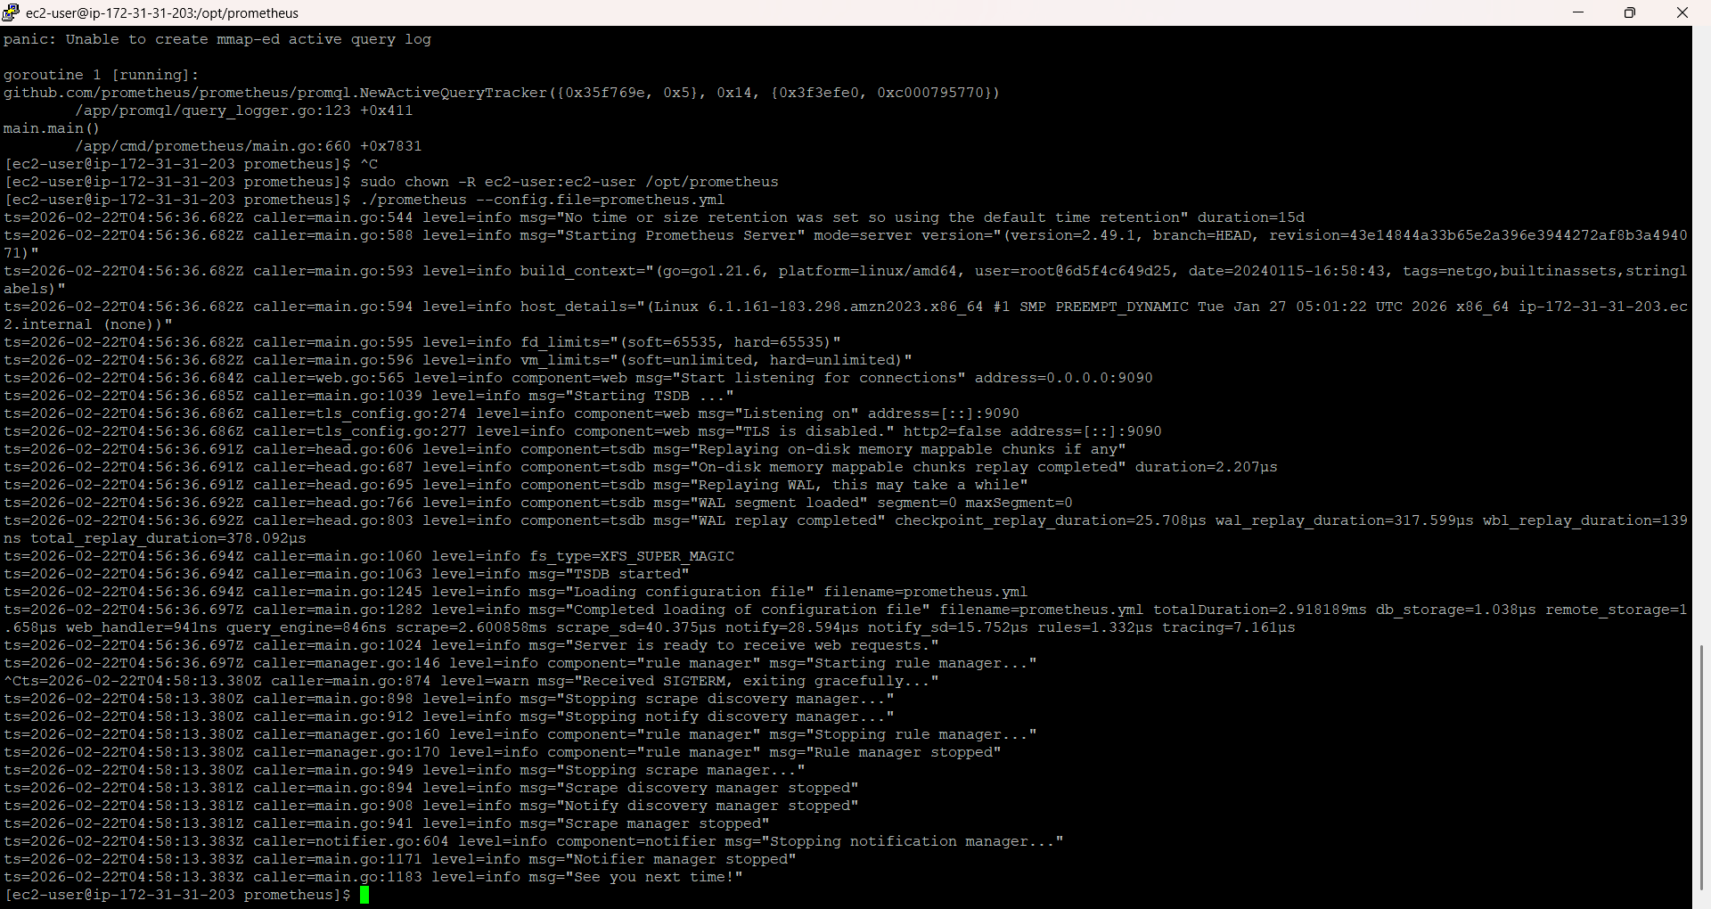

Step 7: Prometheus check in ip http://<EC2-PUBLIC-IP>:9090

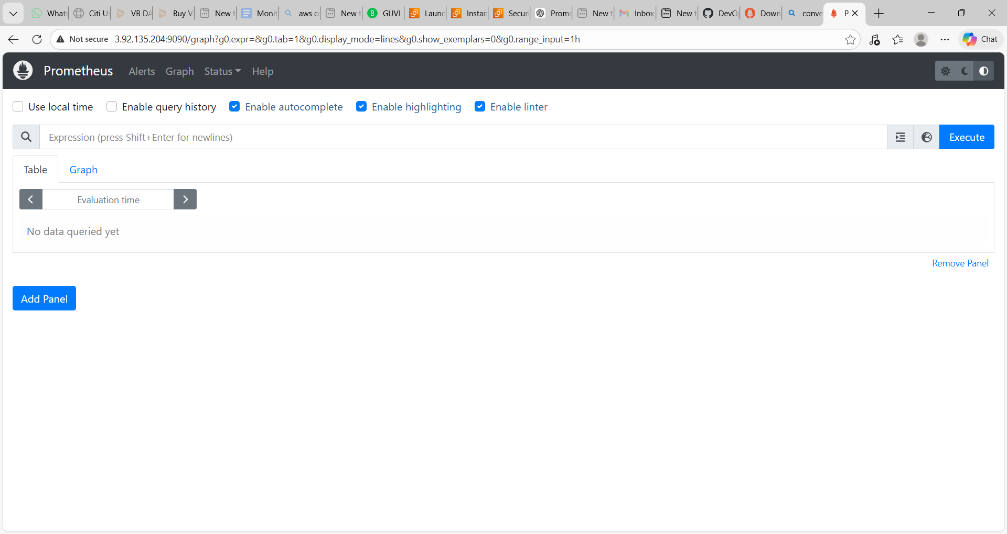

Above step

* It runs only while terminal is open
* If you close SSH → Prometheus stops
* If EC2 restarts → Prometheus stops

For a proper DevOps-style setup, you should run: Prometheus as a systemd service

**Running Promotheus as Service –** By

**Create user**

sudo useradd --no-create-home --shell /bin/false Prometheus

Move binaries:

sudo cp prometheus /usr/local/bin/  
sudo cp promtool /usr/local/bin/

Create service file:

sudo nano /etc/systemd/system/prometheus.service

Paste:

[Unit]

Description=Prometheus

After=network.target

[Service]

User=prometheus

WorkingDirectory=/opt/prometheus

ExecStart=/opt/prometheus/prometheus \

--config.file=/opt/prometheus/prometheus.yml \

--storage.tsdb.path=/opt/prometheus/data

Restart=always

[Install]

WantedBy=multi-user.target

Press Ctrl+0 to save the file and Enter

Press ctrl+X to quit the nano editor

Change the ownership to this user

sudo chown -R prometheus:prometheus /opt/prometheus

Start service:

sudo systemctl daemon-reload  
sudo systemctl start prometheus  
sudo systemctl enable Prometheus

Check status:

sudo systemctl status Prometheus

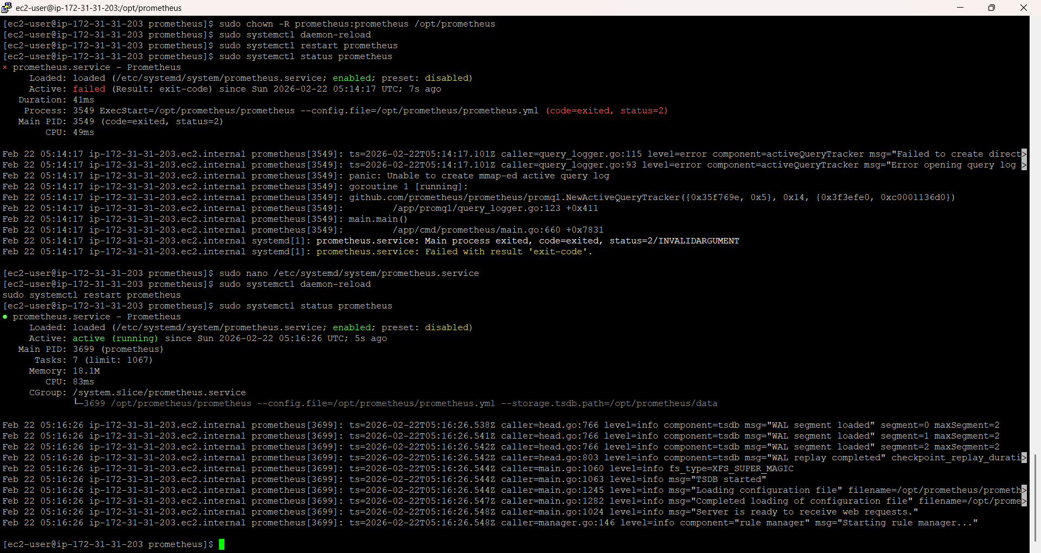

Installing Grafana

sudo yum install -y <https://dl.grafana.com/oss/release/grafana-10.4.0-1.x86_64.rpm>

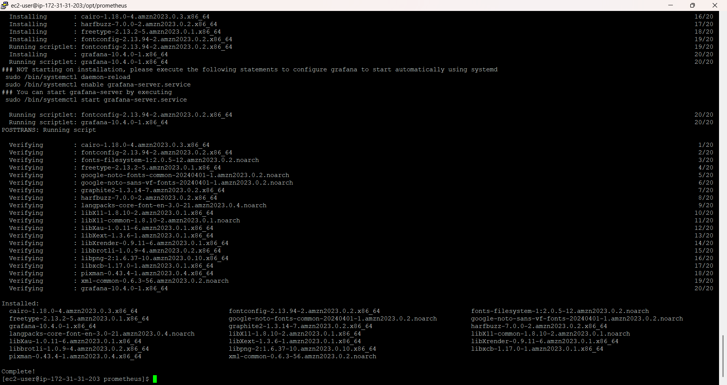

Start Grafana

sudo systemctl start grafana-server

sudo systemctl enable grafana-server

sudo systemctl status grafana-server

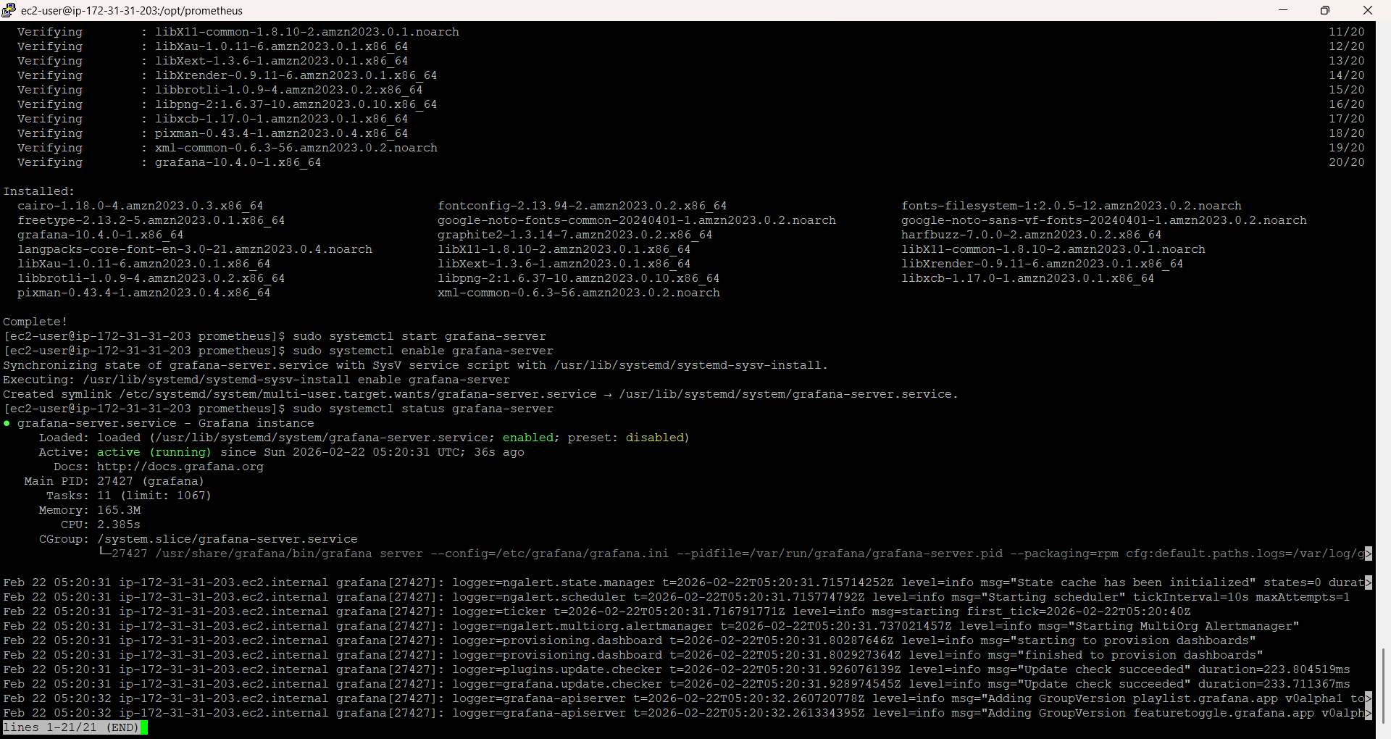

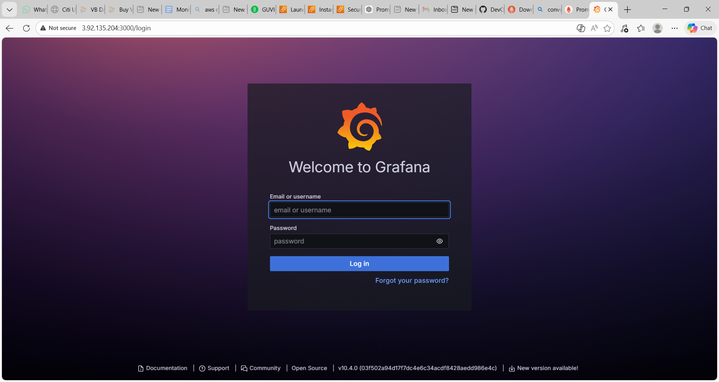

Install node exporter

sudo wget <https://github.com/prometheus/node_exporter/releases/download/v1.7.0/node_exporter-1.7.0.linux-amd64.tar.gz>

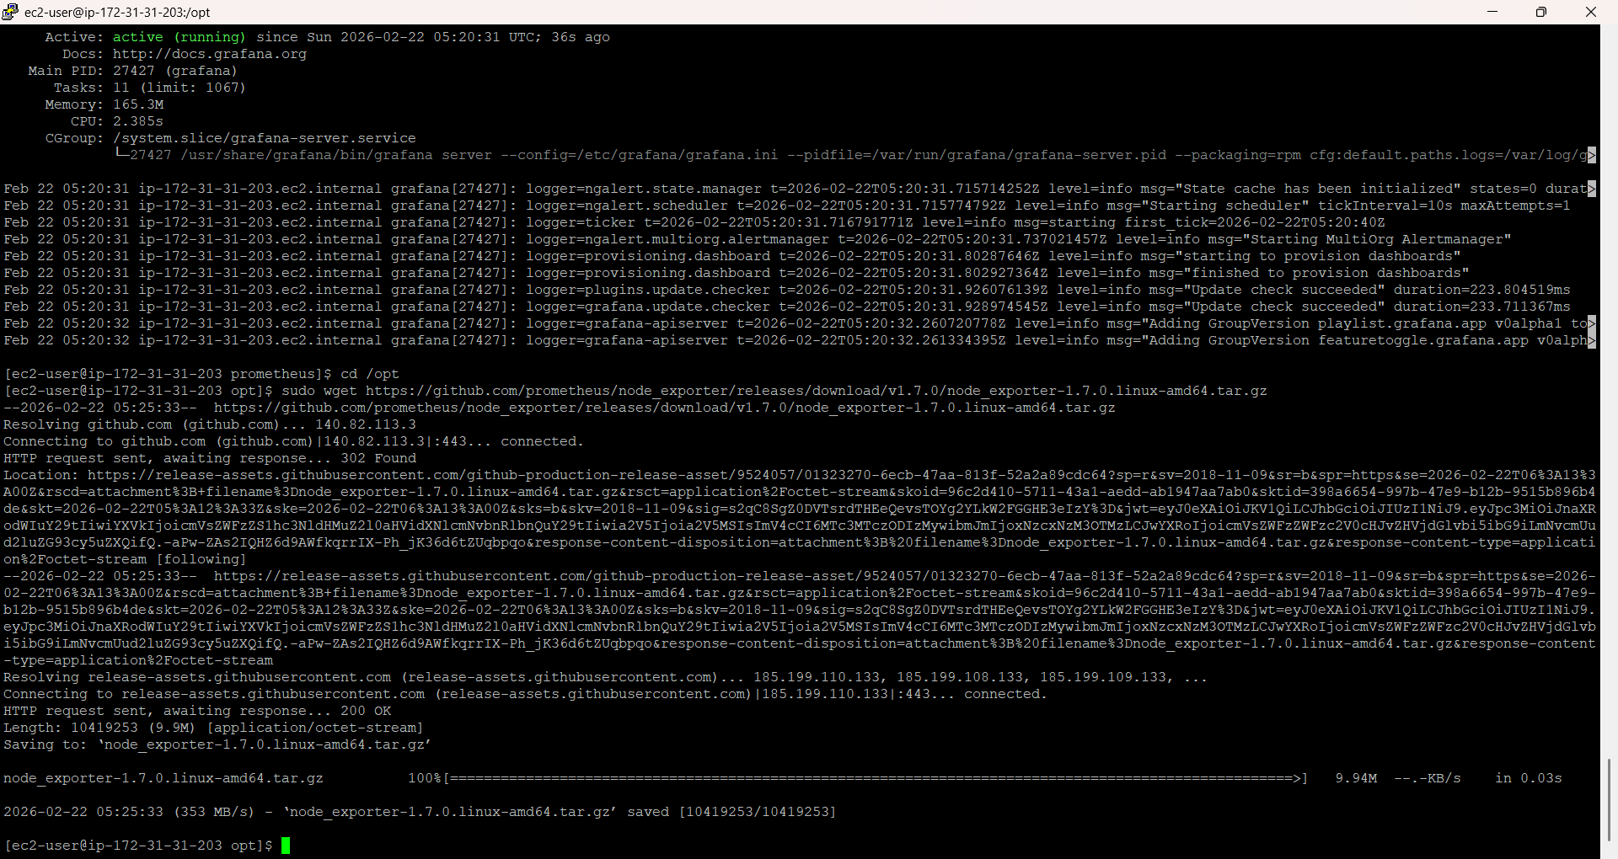

sudo tar -xvf node_exporter-*.tar.gz

sudo mv node_exporter-1.7.0.linux-amd64 node_exporter

Create node exporter usr

sudo useradd --no-create-home --shell /bin/false node_exporter

sudo chown -R node_exporter:node_exporter /opt/node_exporter

Create a service

sudo nano /etc/systemd/system/node_exporter.service

[Unit]

Description=Node Exporter

After=network.target

[Service]

User=node_exporter

WorkingDirectory=/opt/node_exporter

ExecStart=/opt/node_exporter/node_exporter

Restart=always

[Install]

WantedBy=multi-user.target

Start node exporter

sudo systemctl daemon-reload

sudo systemctl start node_exporter

sudo systemctl enable node_exporter

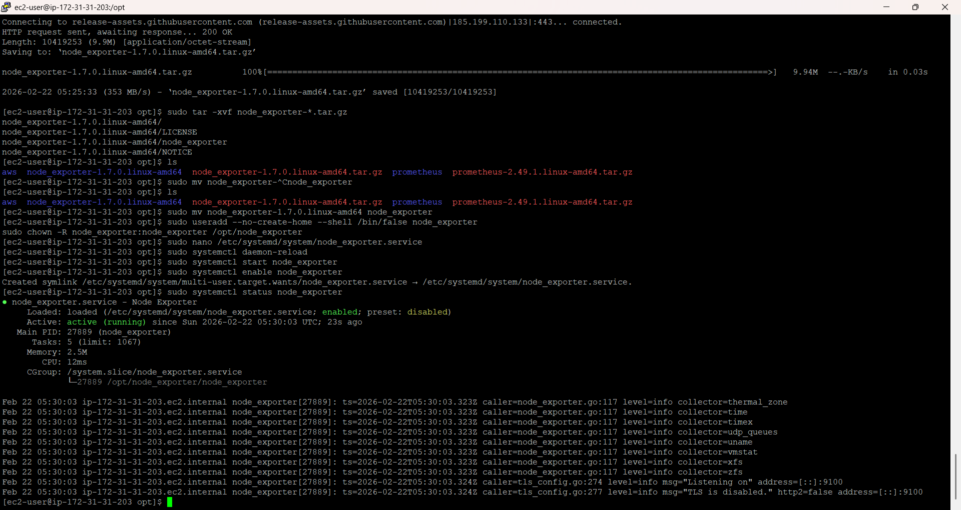

curl http://localhost:9100/metrics | head

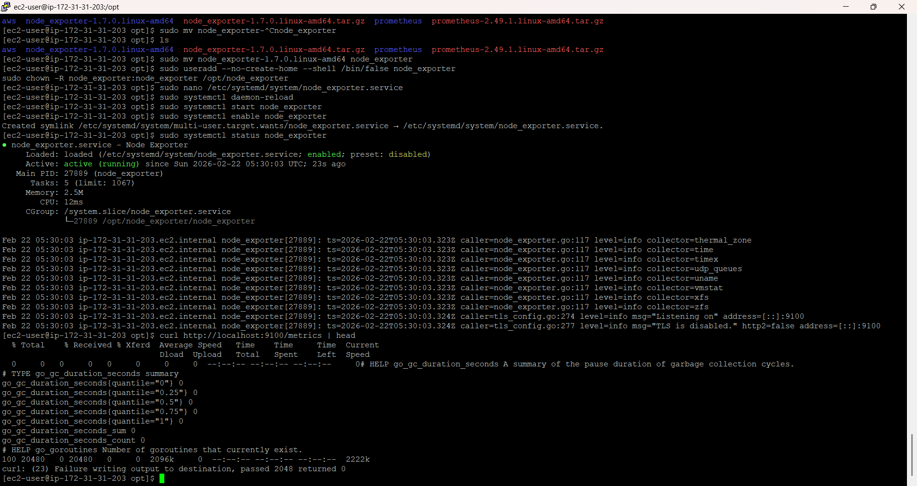

Check status targets in Prometheus

C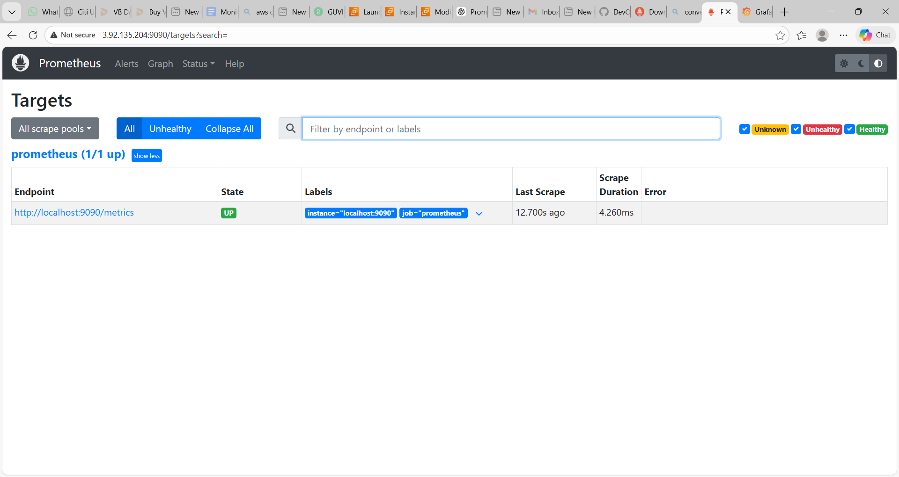

Connect to Grafana username and password are admin

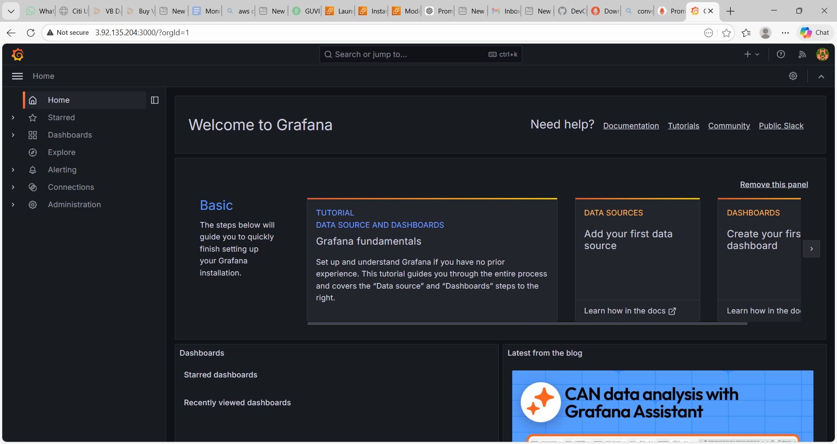

Connections → Data Sources-> add prmetheus

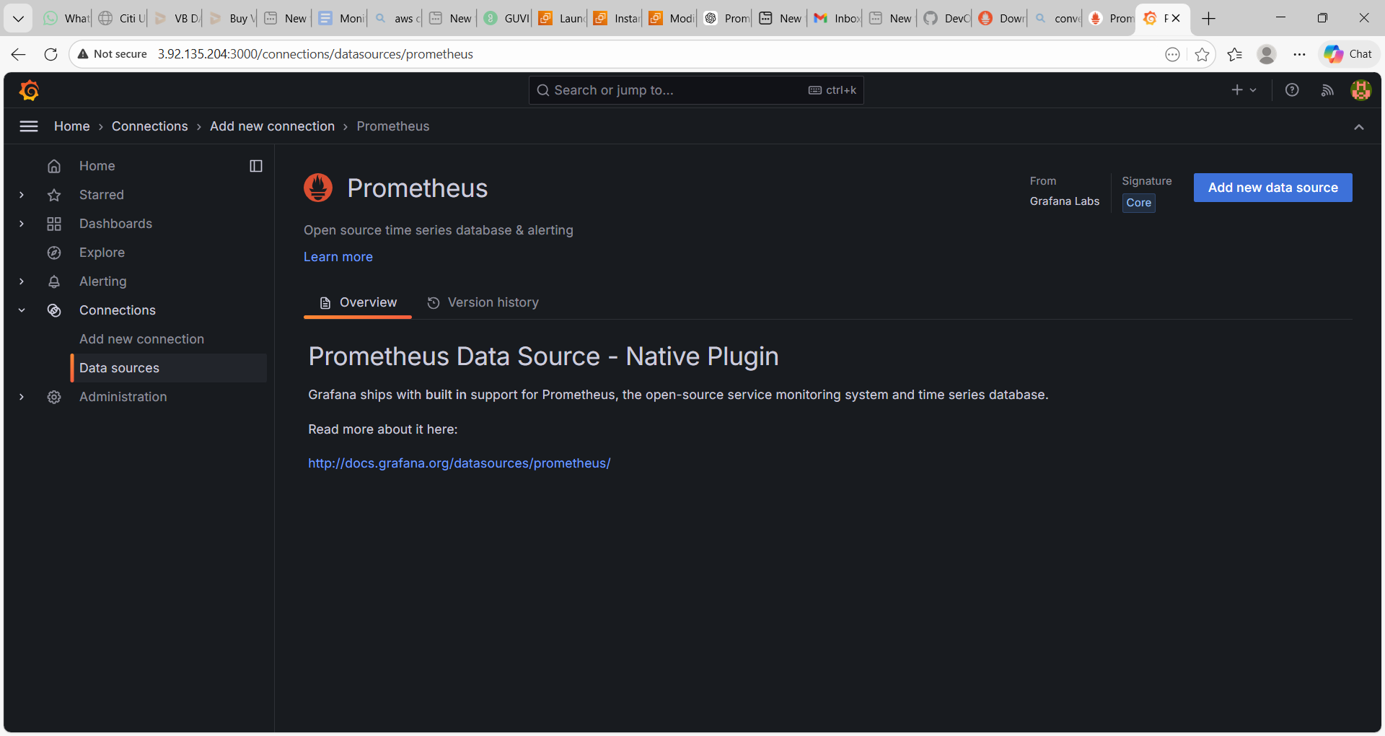

Add Prometheus url -http://localhost:9090 save and test

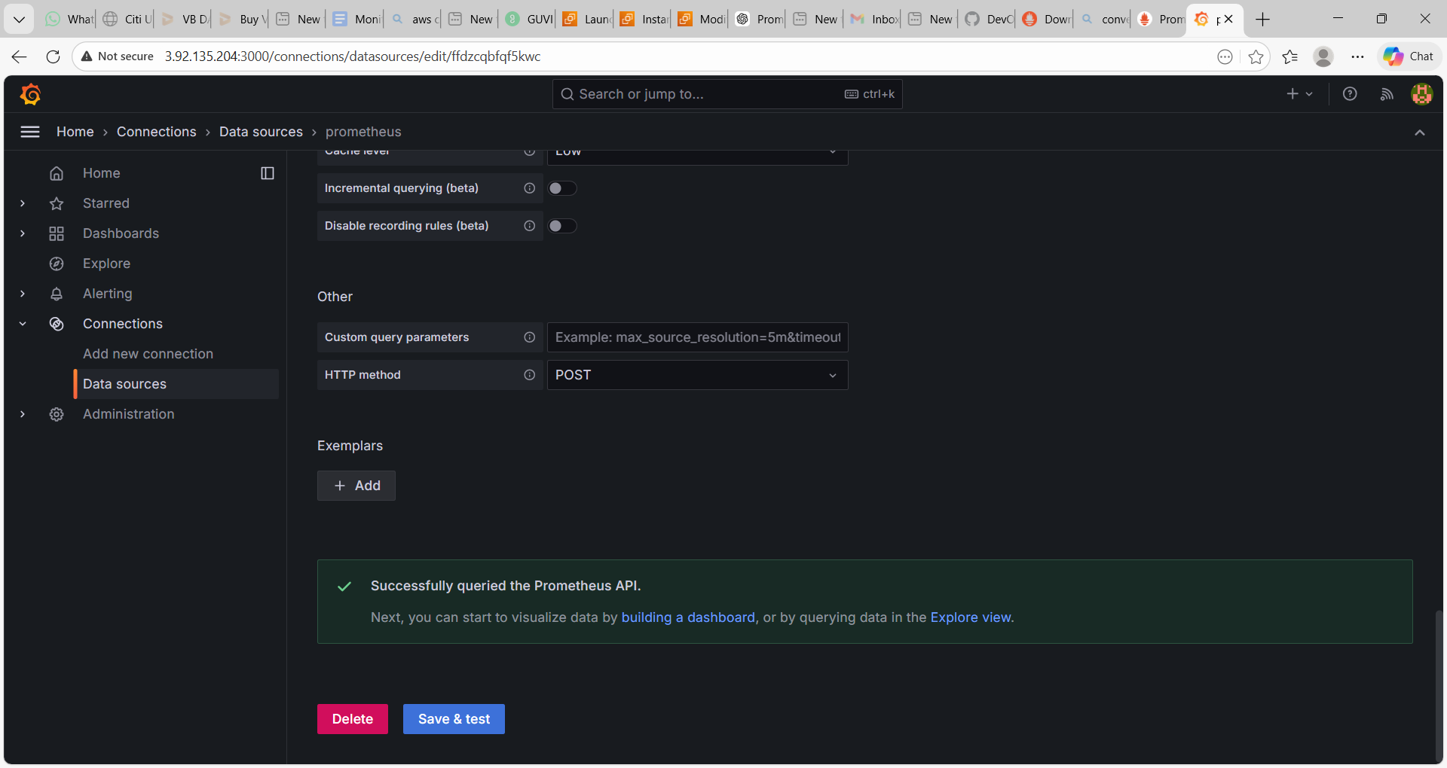

Go to **Dashboards** Click **Import**

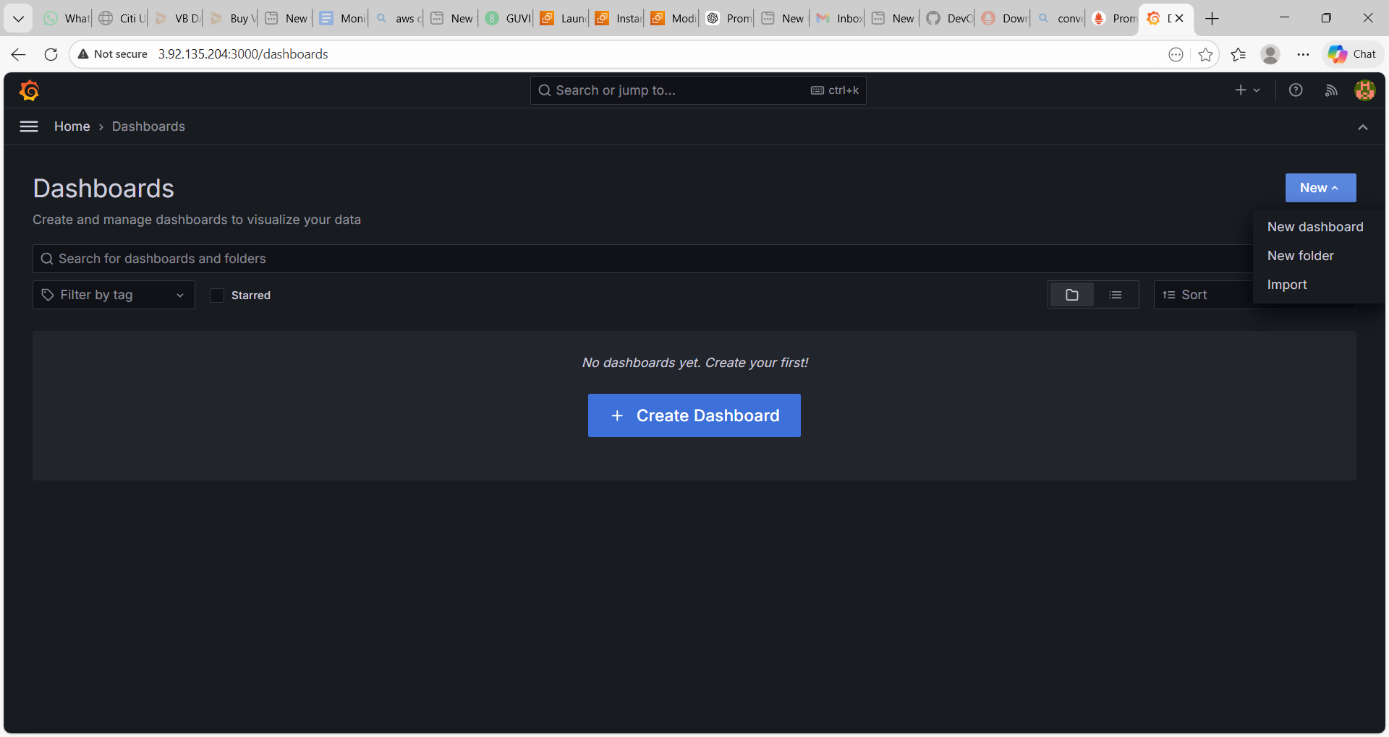

Dashboard id as 1860 – import

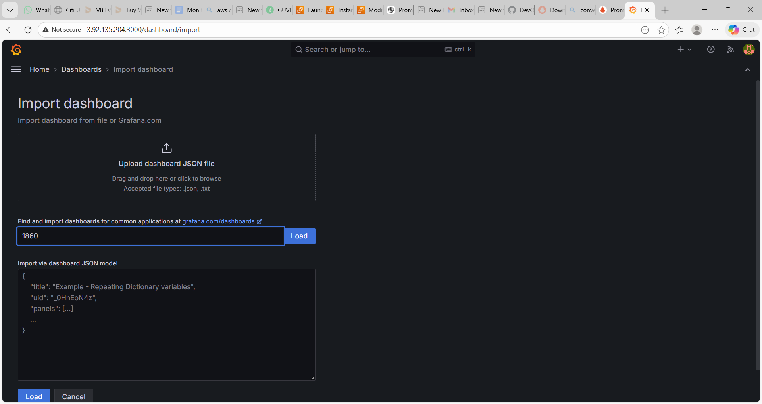

Click Import shows the dashboard in Grafana

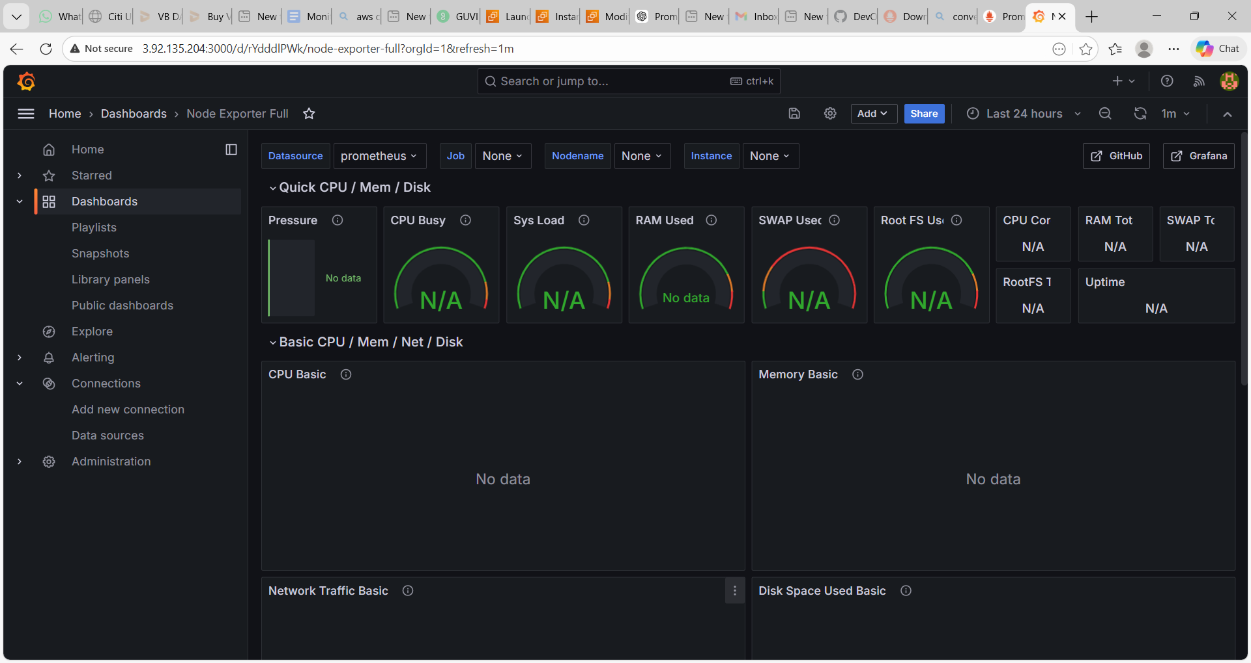

**Add node exporter to promotheus config file**

sudo nano /opt/prometheus/prometheus.yml

- job_name: 'node'  
static_configs:  
- targets: ['localhost:9100']

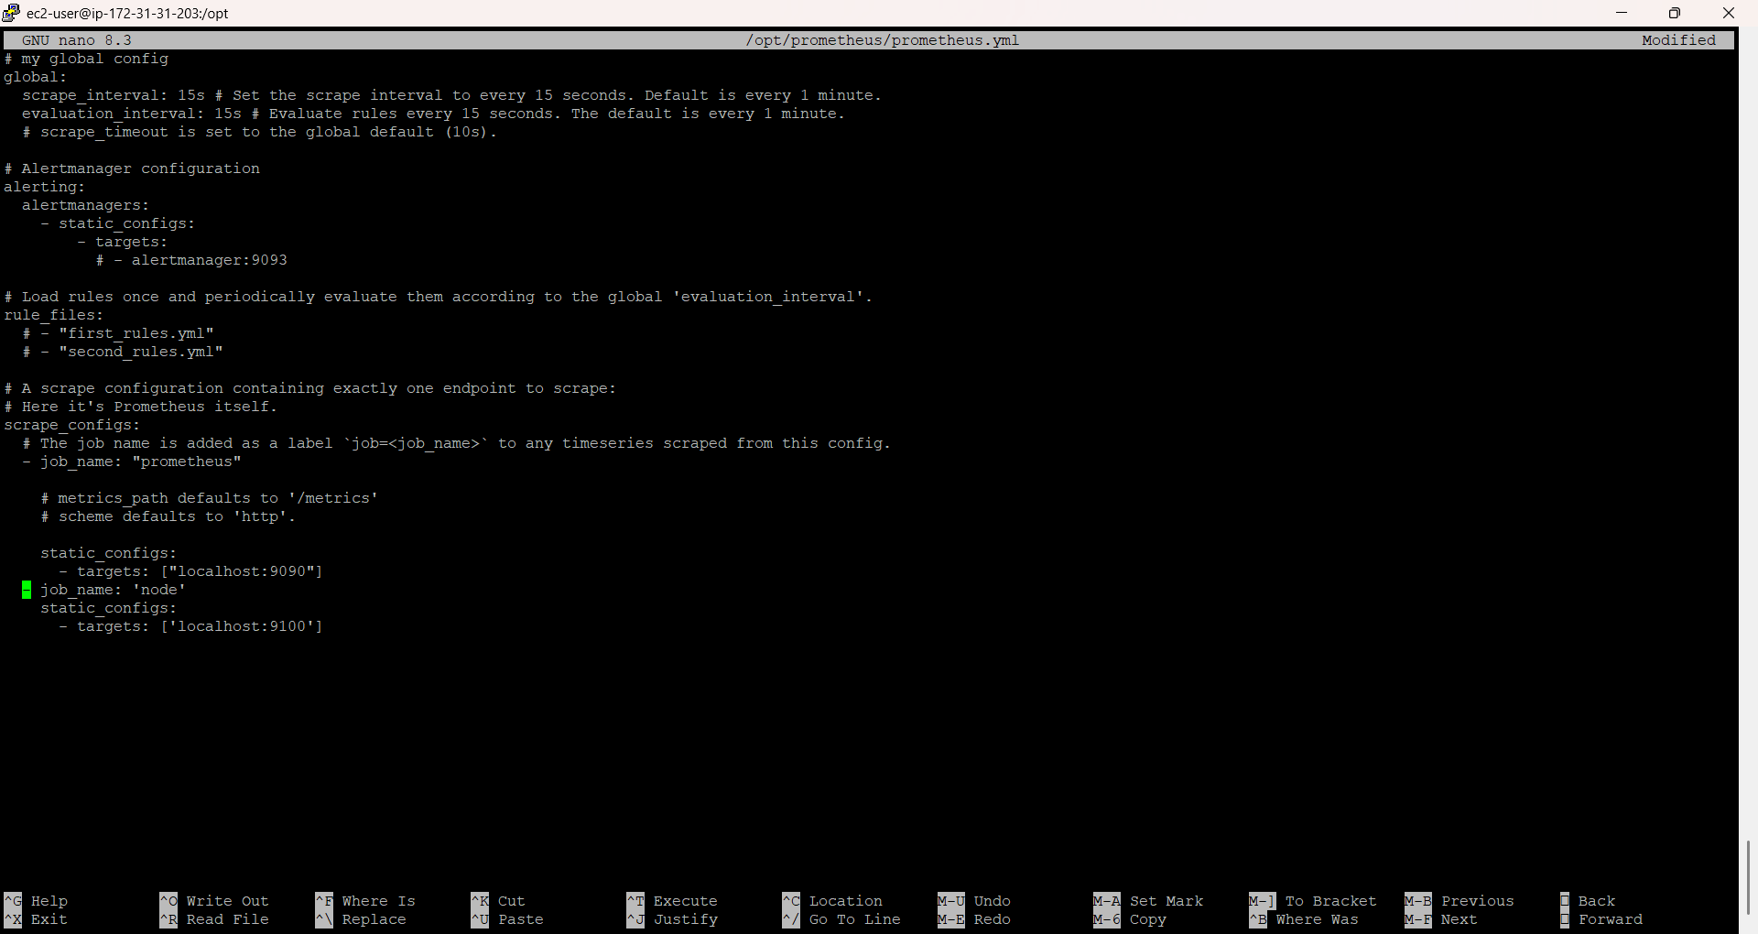

**Refresh Grafana to see the CPU details**

